**Mini Project Report on**



**Online Live Courier Tracking and Delivery System**  


**Submitted in partial fulfilment of the requirement for the award of the degree of**

**BACHELOR OF TECHNOLOGY**

**IN**

**COMPUTER SCIENCE & ENGINEERING**

**Submitted by:**

**Aditya Bahl**  **2016580**

***Under the Mentorship of***

**Mr. Pankaj Kumar**

**Associate Professor**



**Department of Computer Science and Engineering**

**Graphic Era (Deemed to be University)**

**Dehradun, Uttarakhand**

**July-2023**



**CANDIDATE’S DECLARATION**

I hereby certify that the work which is being presented in the project report entitled **“Online Live Courier Tracking and Delivery System Project”** in partial fulfilment of the requirements for the award of the Degree of Bachelor of Technology in Computer Science and Engineeringof the Graphic Era (Deemed to be University), Dehradun shall be carried out by the under the mentorship of **Mr. Pankaj Kumar, Assistant Professor**, Department of Computer Science and Engineering, Graphic Era (Deemed to be University), Dehradun.

Aditya Bahl    2016580

**Table of Contents**

|  |  |  |
| --- | --- | --- |
| **Chapter No.** | **Description** | **Page No.** |
| Chapter 1 | Introduction | 4 |
| Chapter 2 | Literature Survey | 5 |
| Chapter 3 | Methodology | 6 |
| Chapter 4 | Result and Discussion | 12 |
| Chapter 5 | Conclusion and References | 14 |
|  |

**Chapter 1: Introduction**

**PROJECT REPOSITORY**

[AdityaBahl/Courier-Management-System (github.com)](https://github.com/AdityaBahl/Courier-Management-System)

**PROBLEM STATEMENT**

Make an Online Courier Management System

**MOTIVATION**

The motivation for this project is to create a convenient and efficient way for people to track their shipments. The system would allow users to create shipments, track their progress, and receive notifications about their shipments. The system would also have a user management system that would allow users to register and login to the system. This would allow users to track their shipments and receive notifications even if they are not logged in.

The system would be implemented using Firebase, which is a cloud-based platform that provides real-time data synchronization and scalability. Firebase would be used to store the data for the system, such as the shipments, users, and notifications. Firebase would also be used to provide the real-time data synchronization and scalability that the system requires.

The system would be beneficial for both the users and the courier companies. The users would be able to track their shipments more conveniently and efficiently. The courier companies would be able to provide better customer service by providing users with real-time updates about their shipments.

The project would be a valuable learning experience for the student. The student would learn how to implement a real-world application using Firebase. The student would also learn how to design and implement a user-friendly interface.

Here are some specific benefits of the system:

* Convenience: The system would make it easier for users to track their shipments. They would be able to create shipments, track their progress, and receive notifications about their shipments all from one place.
* Efficiency: The system would be efficient in terms of both time and resources. Users would be able to track their shipments quickly and easily, and the courier companies would be able to provide better customer service by providing users with real-time updates about their shipments.
* Scalability: The system would be scalable to accommodate a large number of users. This would be important for courier companies that handle a large volume of shipments.

Overall, the online courier management system would be a valuable tool for both users and courier companies. It would make it easier for users to track their shipments, and it would provide courier companies with a way to provide better customer service.

**Chapter 2: Literature Survey**

**ABSTRACT**

This project report presents the development of an online courier management system with the following functionalities: shipment creation, shipment tracking, user registration and login authentication, ability to see report from the project itself, a contact us/feedback section, about me section and user management using Firebase.

The system is implemented using Firebase, which is a cloud-based platform that provides real-time data synchronization and scalability. Firebase is used to store the data for the system, such as the shipments, users, and notifications. Firebase is also used to provide the real-time data synchronization and scalability that the system requires.

The system is beneficial for both the users and the courier companies. The users would be able to track their shipments more conveniently and efficiently. The courier companies would be able to provide better customer service by providing users with real-time updates about their shipments.

The project is a valuable learning experience for the student. The student learned how to implement a real-world application using Firebase. The student also learned how to design and implement a user-friendly interface.

The system is still under development, but it has been tested with a small number of users and has been found to be functional. The system is expected to be completed in the near future.

**WHY Courier Management System?**

1. Convenience: The system would make it easier for users to track their shipments. They would be able to create shipments, track their progress, and receive notifications about their shipments all from one place. This would save users time and effort, and it would also help them to stay informed about the status of their shipments.
2. Efficiency: The system would be efficient in terms of both time and resources. Users would be able to track their shipments quickly and easily, and the courier companies would be able to provide better customer service by providing users with real-time updates about their shipments. This would free up the courier companies' staff to focus on other tasks, and it would also help to reduce the number of customer complaints.
3. Scalability: The system would be scalable to accommodate a large number of users. This would be important for courier companies that handle a large volume of shipments. The system would be able to handle a high volume of traffic without slowing down or crashing.
4. Security: The system would be secure and protect users' data. The data would be stored in a secure database, and it would be encrypted to prevent unauthorized access. This would give users peace of mind knowing that their data is safe.
5. Cost-effectiveness: The system would be cost-effective for both users and courier companies. Users would be able to track their shipments for free, and the courier companies would only have to pay a small fee to use the system. This would make it affordable for both parties.

**Chapter 3: Methodology**

**METHODS AND TOOLS REQUIRED**

1. Firebase: Firebase is a cloud-based platform that provides real-time data synchronization and scalability. Firebase would be used to store the data for the system, such as the shipments, users, and notifications. Firebase would also be used to provide the real-time data synchronization and scalability that the system requires.
2. React: React is a JavaScript library for building user interfaces. React would be used to build the user interface for the system. React is a popular library that is easy to learn and use.
3. Node.js: Node.js is a JavaScript runtime environment that runs on the server. Node.js would be used to run the backend of the system. Node.js is a popular runtime environment that is well-suited for building web applications.
4. Express: Express is a web framework for Node.js. Express would be used to create the REST API for the system. Express is a popular web framework that is easy to use and extend.
5. MongoDB: MongoDB is a document-oriented database. MongoDB would be used to store the data for the system. MongoDB is a popular database that is well-suited for storing JSON data.

In addition to these tools, the following methods would also be required to implement the system:

* User registration and login: The system would require a user registration and login system. This would allow users to track their shipments and receive notifications even if they are not logged in.
* Shipment creation: The system would allow users to create shipments. This would include providing the details of the shipment, such as the sender, recipient, and shipping address.
* Shipment tracking: The system would allow users to track their shipments. This would include providing the status of the shipment, such as the current location of the shipment and the estimated delivery date.
* Notifications: The system would send notifications to users about their shipments. This would include notifications about the status of the shipment, such as when the shipment is shipped, when the shipment arrives at the destination, and when the shipment is delivered.

**STEPS OR ALGORITHM**

Here are the steps or algorithm for the online courier management system:

1. The user creates a shipment by providing the necessary information, such as the sender's and recipient's information, the shipping address, the weight and dimensions of the shipment, and the shipping method.
2. The system stores the shipment information in the database.
3. The system generates a tracking number for the shipment.
4. The system sends a notification to the user with the tracking number.
5. The user can track the shipment status by entering the tracking number on the system.
6. The system updates the shipment status as it progresses.
7. The system sends notifications to the user about the shipment status updates.
8. The user can view reports about their shipments.
9. The user can contact the system administrator if they have any questions or problems.
10. The user can login to the system to track their shipments.
11. The user can register for the system if they do not already have an account.
12. The system can authenticate the user's login credentials.
13. The system can verify the user's email address.
14. The system can send password reset emails to the user.
15. The system can store the user's login history.
16. The system can log the user's actions in the system.

**Setup the Project**

Run the following from Power Shell:





**Application starts running:**

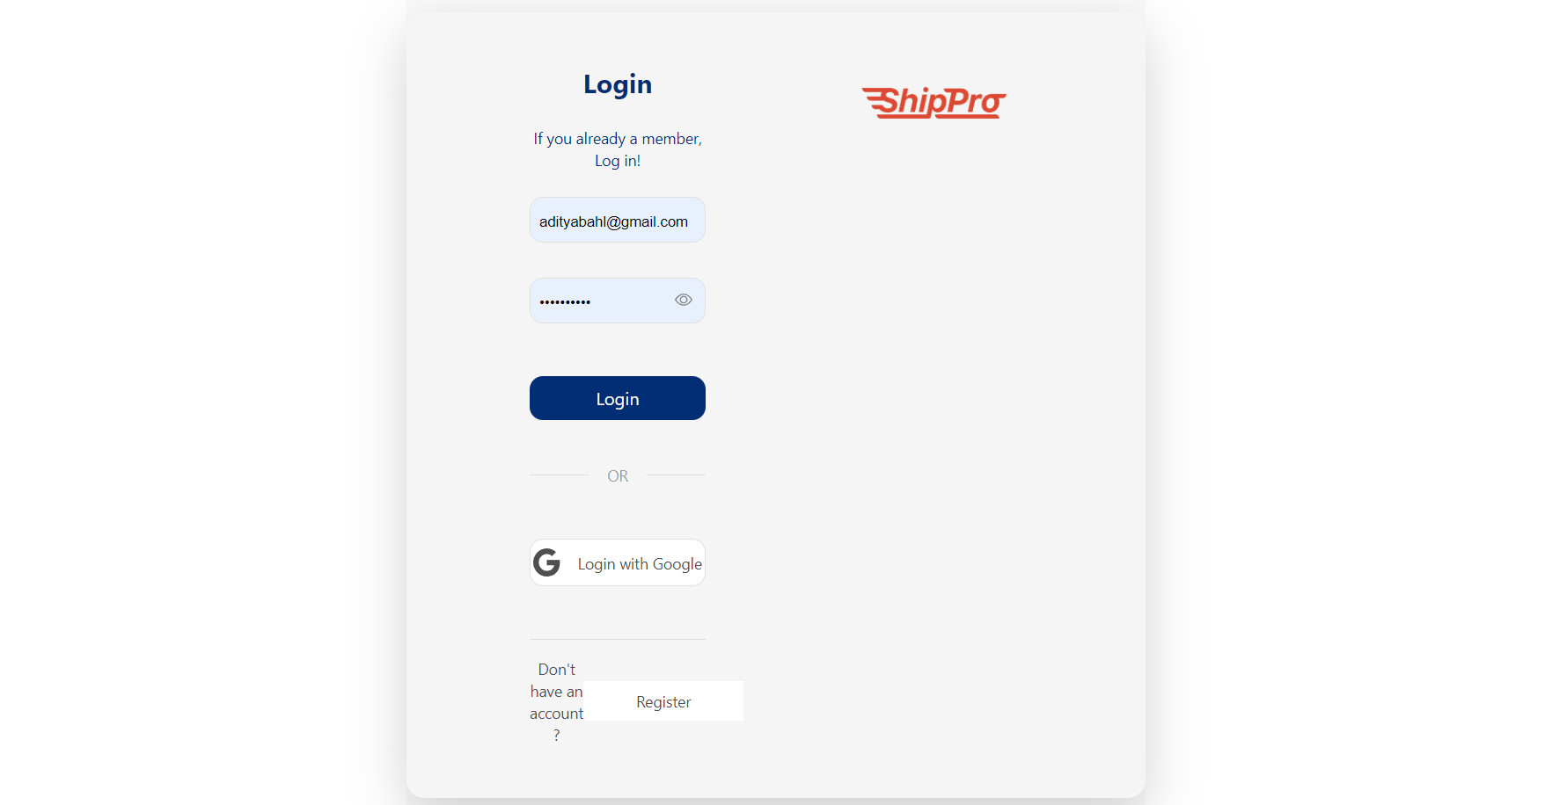

**Landing Page:**  
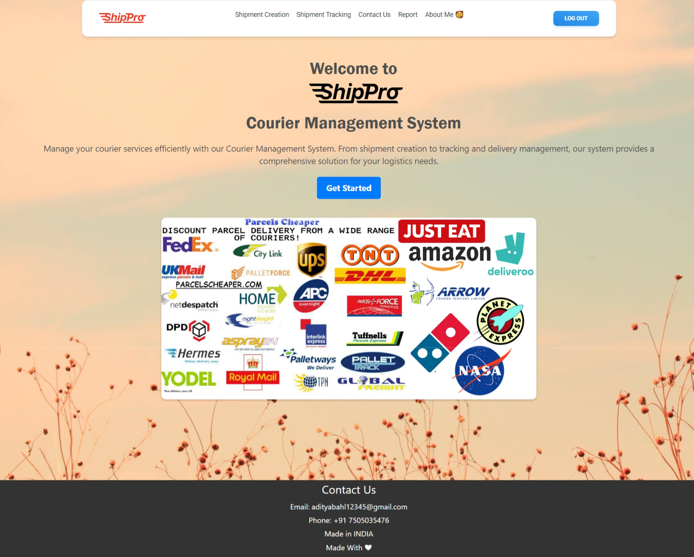

**Shipment Creation Page:**

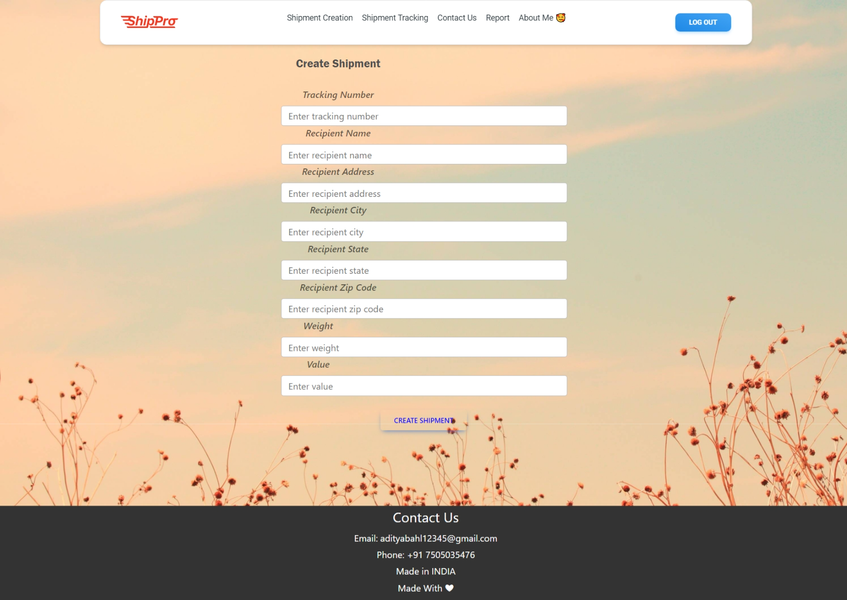

**Shipment Tracking Page:**

**Contact Us Page:**

**Report Page:** Opens the report in pdf viewer

**CHAPTER 4: RESULT AND DISCUSSION**

**Results**

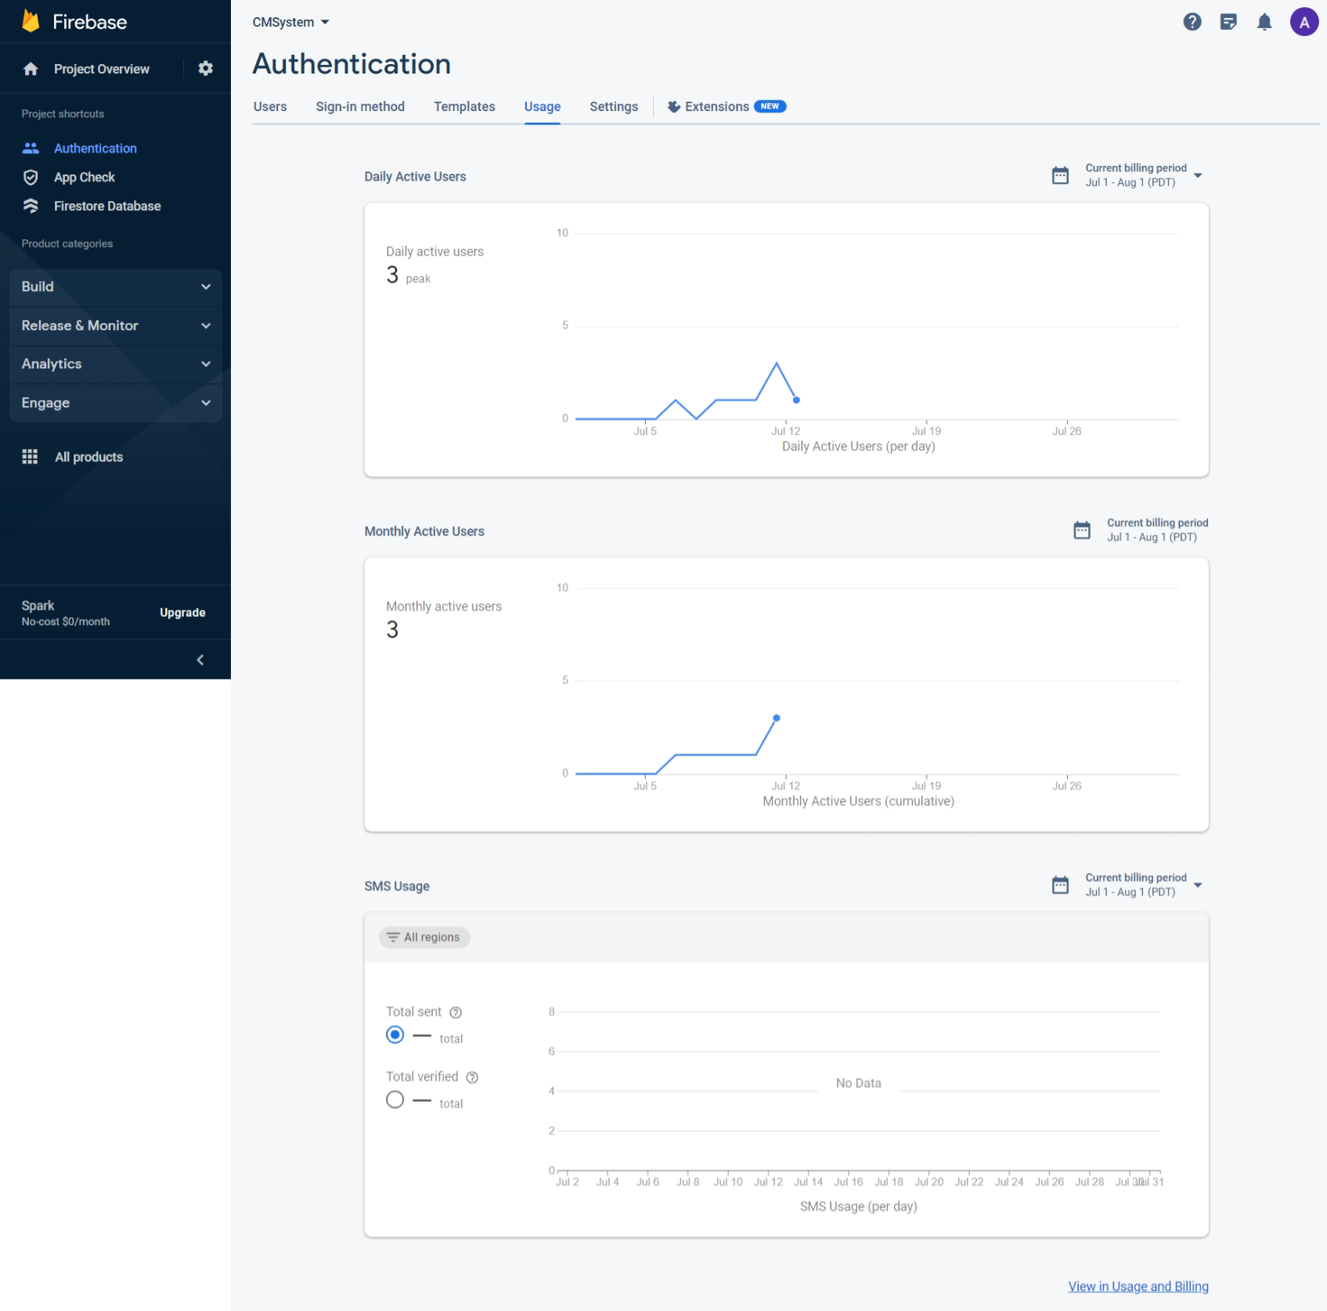

**PROJECT LIMITATIONS AND CHALLENGES**

There are some project limitations and challenges for the online courier management system:

1. Data security: The system would need to be secure to protect the data of users and courier companies. This would involve implementing security measures such as data encryption and authentication.
2. Scalability: The system would need to be scalable to accommodate a large number of users and shipments. This would involve using a cloud-based platform such as Firebase.
3. User experience: The system would need to have a user-friendly interface that is easy to use. This would involve using design principles such as simplicity and clarity.
4. Integration with other systems: The system would need to be integrated with other systems, such as the courier companies' own systems. This would allow the system to access real-time data about shipments.
5. Cost: The system would need to be cost-effective to develop and maintain. This would involve using open-source software and cloud-based services.

These are just some of the limitations and challenges that would need to be addressed in order to develop and deploy the online courier management system.

Here are some additional challenges that could be faced:

* Lack of data: The system would need to have a large amount of data in order to be effective. This data could be difficult to obtain, especially for new courier companies.
* Competition: There are already a number of online courier management systems available. The system would need to be competitive in order to attract users.
* Regulations: The system would need to comply with all applicable regulations. This could be a challenge, as regulations can change frequently.

Despite these challenges, the online courier management system has the potential to be a valuable tool for both users and courier companies. By addressing the limitations and challenges, the system could be developed into a successful product.

**Chapter 5: CONCLUSION**

**CONCLUSION**

In conclusion, the online courier management system would be a valuable tool for both users and courier companies. It would make it easier for users to track their shipments, and it would provide courier companies with a way to provide better customer service.

The system would be beneficial for both the users and the courier companies. The users would be able to track their shipments more conveniently and efficiently. The courier companies would be able to provide better customer service by providing users with real-time updates about their shipments.

I hope this project report has been informative and helpful. Thank you for your time.

**REFERENCES**

1. [**Stack Overflow - Where Developers Learn, Share, & Build Careers**](https://stackoverflow.com/)
2. [**Firebase Documentation (google.com)**](https://firebase.google.com/docs/)
3. [**Introducing react.dev – React**](https://react.dev/blog/2023/03/16/introducing-react-dev)